11. Container With Most Water

You are given an integer array height of length n. There are n vertical lines drawn such that the

two endpoints of the ith line are (i, 0) and (i, height[i]).

Find two lines that together with the x-axis form a container, such that the container contains the

most water.

Return the maximum amount of water a container can store.

Notice that you may not slant the container.

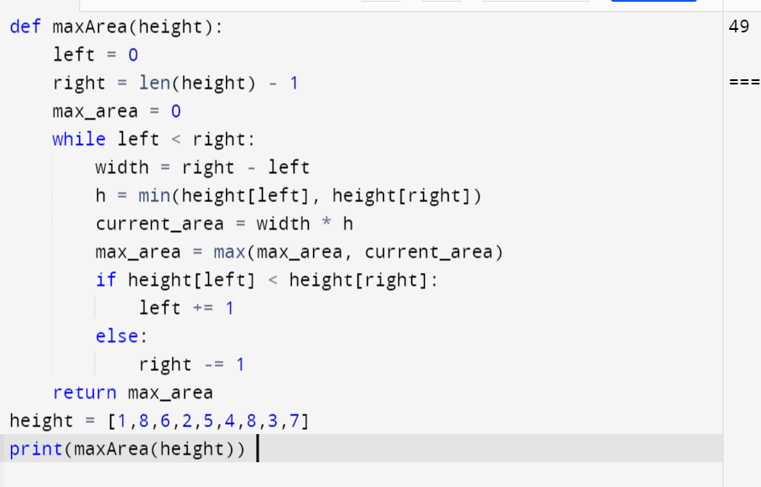

12. Integer to Roman

Roman numerals are represented by seven different symbols: I, V, X, L, C, D and M.

Symbol Value

I 1

V 5

X 10

L 50

C 100

D 500

M 1000

For example, 2 is written as II in Roman numeral, just two one's added together. 12 is written as

XII, which is simply X + II. The number 27 is written as XXVII, which is XX + V + II.

Roman numerals are usually written largest to smallest from left to right. However, the numeral

for four is not IIII. Instead, the number four is written as IV. Because the one is before the five

we subtract it making four. The same principle applies to the number nine, which is written as

IX. There are six instances where subtraction is used:

● I can be placed before V (5) and X (10) to make 4 and 9.

● X can be placed before L (50) and C (100) to make 40 and 90.

● C can be placed before D (500) and M (1000) to make 400 and 900.

Given an integer, convert it to a roman numeral.

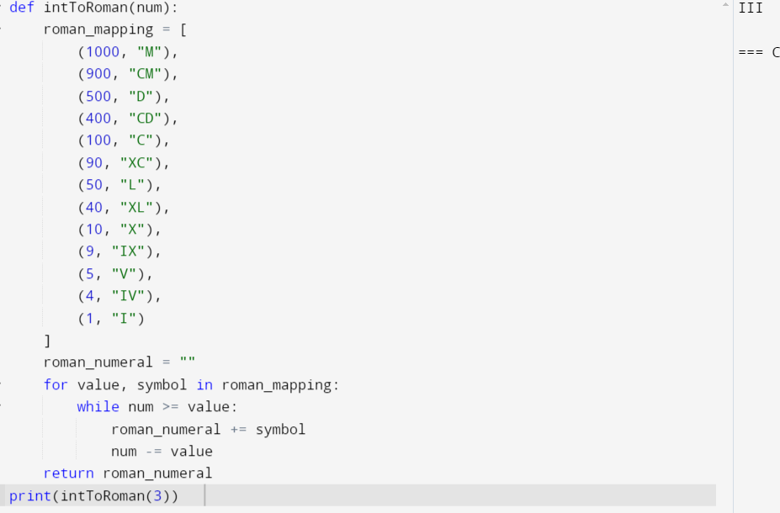

13. Roman to Integer

Roman numerals are represented by seven different symbols: I, V, X, L, C, D and M.

Symbol Value

I 1

V 5

X 10

L 50

C 100

D 500

M 1000

For example, 2 is written as II in Roman numeral, just two ones added together. 12 is written as

XII, which is simply X + II. The number 27 is written as XXVII, which is XX + V + II.

Roman numerals are usually written largest to smallest from left to right. However, the numeral

for four is not IIII. Instead, the number four is written as IV. Because the one is before the five

we subtract it making four. The same principle applies to the number nine, which is written as

IX. There are six instances where subtraction is used:

● I can be placed before V (5) and X (10) to make 4 and 9.

● X can be placed before L (50) and C (100) to make 40 and 90.

● C can be placed before D (500) and M (1000) to make 400 and 900.

Given a roman numeral, convert it to an integer.

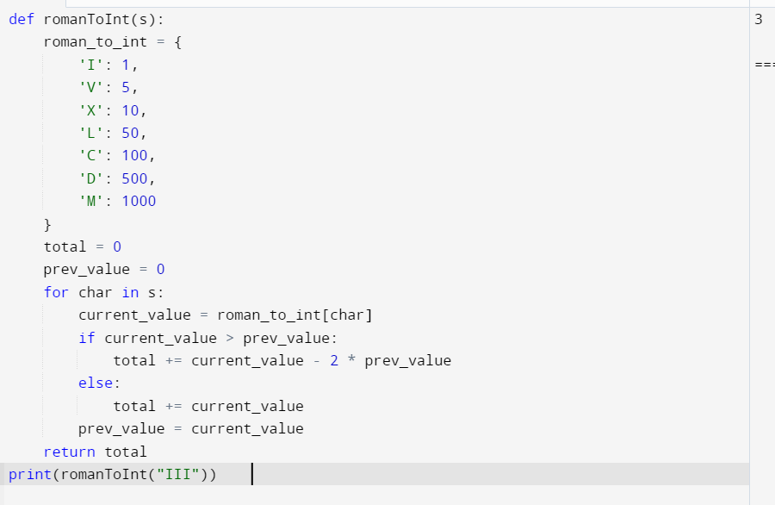

14. Longest Common Prefix

Write a function to find the longest common prefix string amongst an array of strings.

If there is no common prefix, return an empty string "".

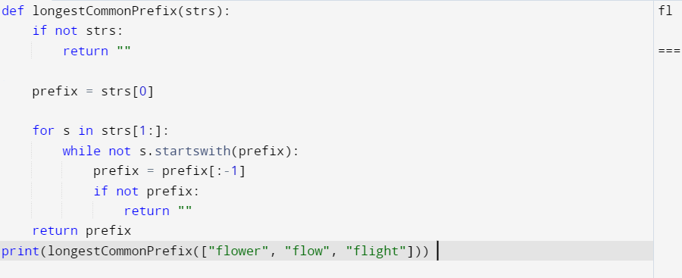

15. 3Sum

Given an integer array nums, return all the triplets [nums[i], nums[j], nums[k]] such that i != j, i

!= k, and j != k, and nums[i] + nums[j] + nums[k] == 0.

Notice that the solution set must not contain duplicate triplets.

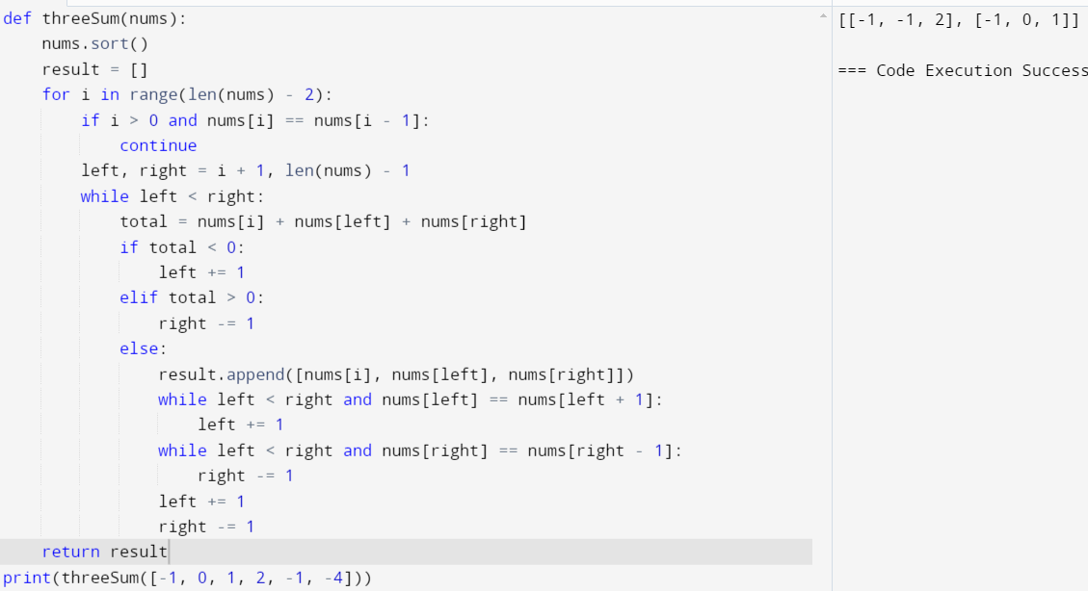

16. 3Sum Closest

Given an integer array nums of length n and an integer target, find three integers in nums such

that the sum is closest to target.

Return the sum of the three integers.

You may assume that each input would have exactly one solution.

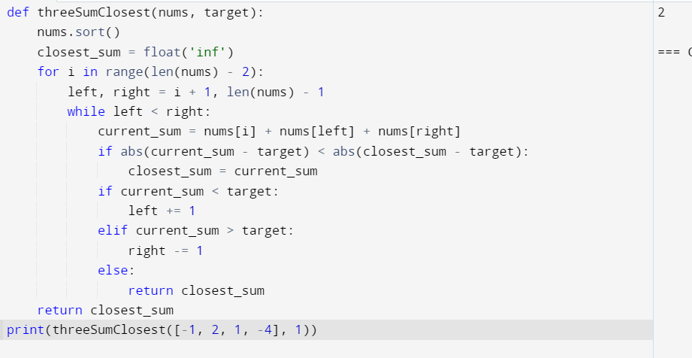

17. Letter Combinations of a Phone Number

Given a string containing digits from 2-9 inclusive, return all possible letter combinations that

the number could represent. Return the answer in any order.

A mapping of digits to letters (just like on the telephone buttons) is given below. Note that 1

does not map to any letters.

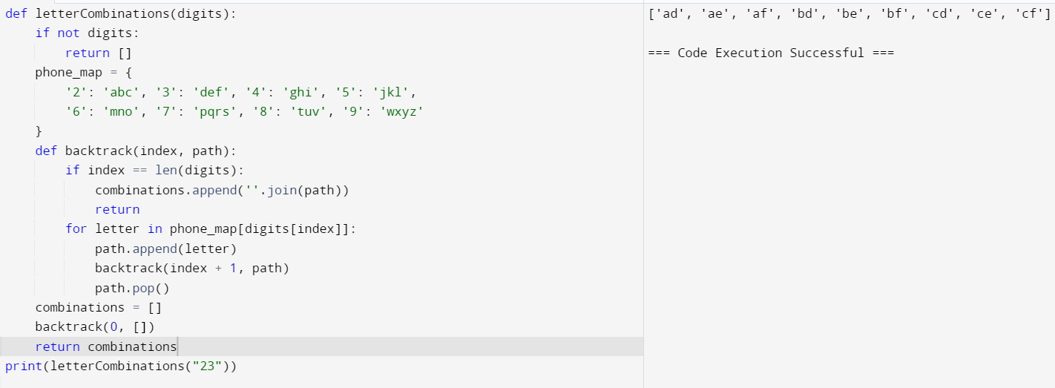

18. 4Sum

Given an array nums of n integers, return an array of all the unique quadruplets [nums[a],

nums[b], nums[c], nums[d]] such that:

● 0 <= a, b, c, d < n

● a, b, c, and d are distinct.

● nums[a] + nums[b] + nums[c] + nums[d] == target

You may return the answer in any order.

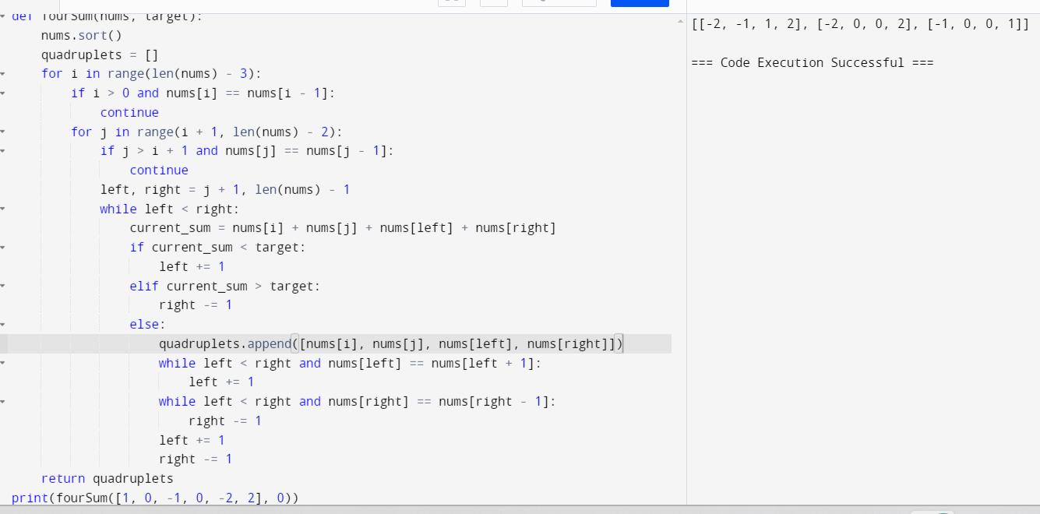

19. Remove Nth Node From End of List

Given the head of a linked list, remove the nth node from the end of the list and return its head.

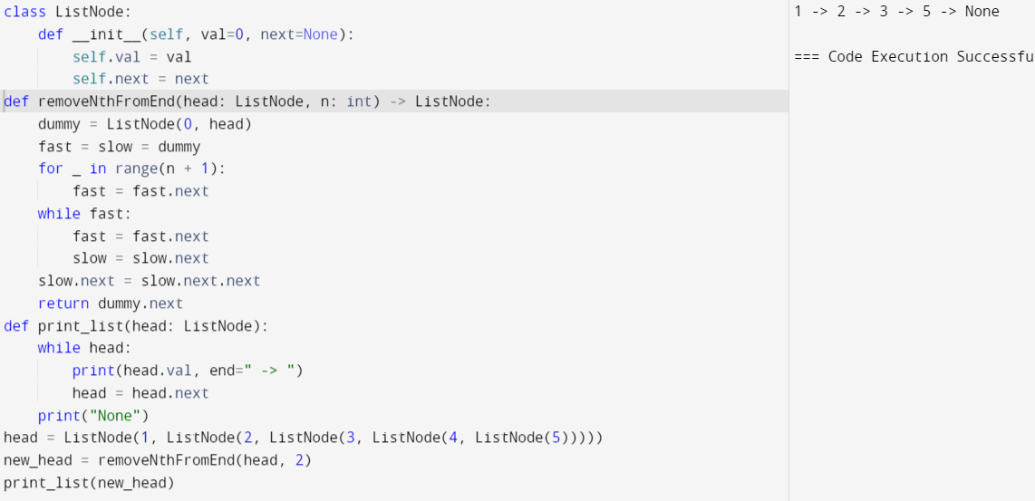

20. Valid Parentheses

Given a string s containing just the characters '(', ')', '{', '}', '[' and ']', determine if the input string

is valid.

